**Software requirements document**

***Software Requirements Specification***

**Version 1.0**

**Course: Web Designing and Development**

**Prepared by: Ateeb-ur-Rehman**

**Date: 2023-08-12**

**TEAM MEMBERS**

|  |  |  |
| --- | --- | --- |
| BABAR QURESHI | Student1454640 | babaraptech01@gmail.com |
| RASBA NADEEM | 1460048 | Rasbanadeem@gmail.com |
| OSAMA SHAHID | 788-23-1463639 | Starz1482@gmail.com |
| ATEEB UR REHMAN | 788-23-1465510 | ateebkhann@hotmail.com |
| NAMEER ASIF | 788-23-1459606 | NameerAsif@gmail.com |
| HIRA ARIF | 788-23-1449716 | HiraArif@gmail.com |

**FACULTY: SIR ZAIN AHMED**

**Software Requirements Specification for**

**Page ii Contents**

**Contents**

1 Background and Necessity for the Website ....................................

1.2 Proposed Solution.........................................................................

1.3 Purpose of the Document .............................................................

1.4 Scope of Project............................................................................

1.5 Constraints....................................................................................

1.6 Functional Requirements...............................................................

1.7 Non-Functional Requirements.......................................................

1.8.1 Hardware ......................................................................................

1.8.2 Software........................................................................................

**1. Background and Necessity for the Website**

The Ecommerce Plants Website is a website that allows users to buy and sell plants online. The website was created in response to the growing demand for online plant shopping. In recent years, there has been a surge in interest in indoor plants, as people have turned to plants to improve their air quality and create a more relaxing environment in their homes. The Ecommerce Plants Website aims to meet this demand by providing a convenient and affordable way for people to buy plants online.

**1.2 Proposed Solution**

The Ecommerce Plants Website will be a fully-functional online store that allows users to browse a wide variety of plants, add them to their cart, and checkout securely. The website will also feature a blog with articles on plant care and maintenance, as well as a forum where users can ask questions and share tips with each other.

**1.3 Purpose of the Document**

This document outlines the website delivery process for the Ecommerce Plants Website. It includes a detailed plan for the development, testing, and deployment of the website. The document also identifies the roles and responsibilities of the various stakeholders involved in the project.

**1.4 Scope of Project**

The scope of the project includes the following:

* Development of the website's front-end
* Testing of the website for functionality and security

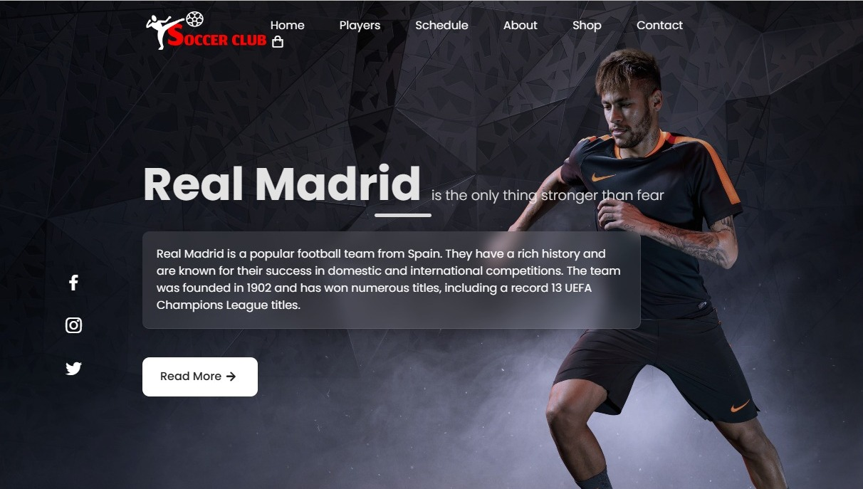

* 1. **Background and Necessity for the Website**
* **Global Popularity:** Soccer is the world's most popular sport, with a massive following across continents.
* **Passionate Community:** Soccer has a passionate and engaged fan base that seeks information, updates, and discussions about matches, players, teams, and related topics.
* **Diverse Conten**t**:** The sport encompasses various aspects, including matches, player profiles, team news, tactics, strategies, history, and cultural impact, providing a rich pool of content to explore.
* **International Events:** Major tournaments like the FIFA World Cup, UEFA European Championship, Copa America, and continental leagues draw global attention, creating a need for a centralized platform for fans.
* **Emerging Leagues:** Soccer is gaining popularity in regions beyond its traditional strongholds, highlighting the demand for information about lesser-known leagues and teams.
* **Comprehensive Information:** Our soccer website serves as a hub for comprehensive and up-to-date information about matches, teams, players, schedules, scores, and statistics.
* **News and Updates:** Fans can rely on our soccer website which will provide them with real-time news, breaking stories, transfer updates, and injury reports about their favorite players and teams.
* **Fan Engagement:** Soccer Club offers a platform for fans to engage in discussions, share opinions, and connect with like-minded enthusiasts through forums, comment sections, and social media integration.
* **Player and Team Profiles:** Soccer Club provides detailed profiles of players and teams, including historical data, achievements, playing styles, and career trajectories, catering to fans' desire for in-depth knowledge.
* **Tactical Analysis:** It also provides In-depth analysis of match tactics, formations, strategies, and game insights that appeal to a more analytical fan base interested in understanding the nuances of the sport.
* **Interactive Features:** Our website provides features like live match streaming, score updates, interactive polls, and fantasy leagues to enhance user engagement and keep fans coming back.
* **Historical Features:** Our soccer website offers historical context, archival footage, and memorable moments that contribute to the sport's rich heritage and nostalgia.
* **Youth Development:** Soccer Club highlights the youth academies, training programs, and grassroots soccer initiatives which encourage young talent and promote the growth of the sport.
* **Cultural Impact:** Soccer is deeply intertwined with culture, identity, and societal impact. Through our website, you can explore these connections, showcasing how soccer influences art, music, fashion, and more.

**1.2 Proposed Solution**

* **User-Friendly Interface:** We have designed an intuitive and user-friendly interface that caters to both casual fans and die-hard soccer enthusiasts.
* **Comprehensive Fixture Information:** Our website displays upcoming matches, schedules, and results for various leagues and tournaments. It also provides detailed match previews, including team line-ups, key player information, and match analysis.
* **Player Profiles and Stats:** Our website provides individual players’ profiles showcasing career statistics, achievements, and current form
* 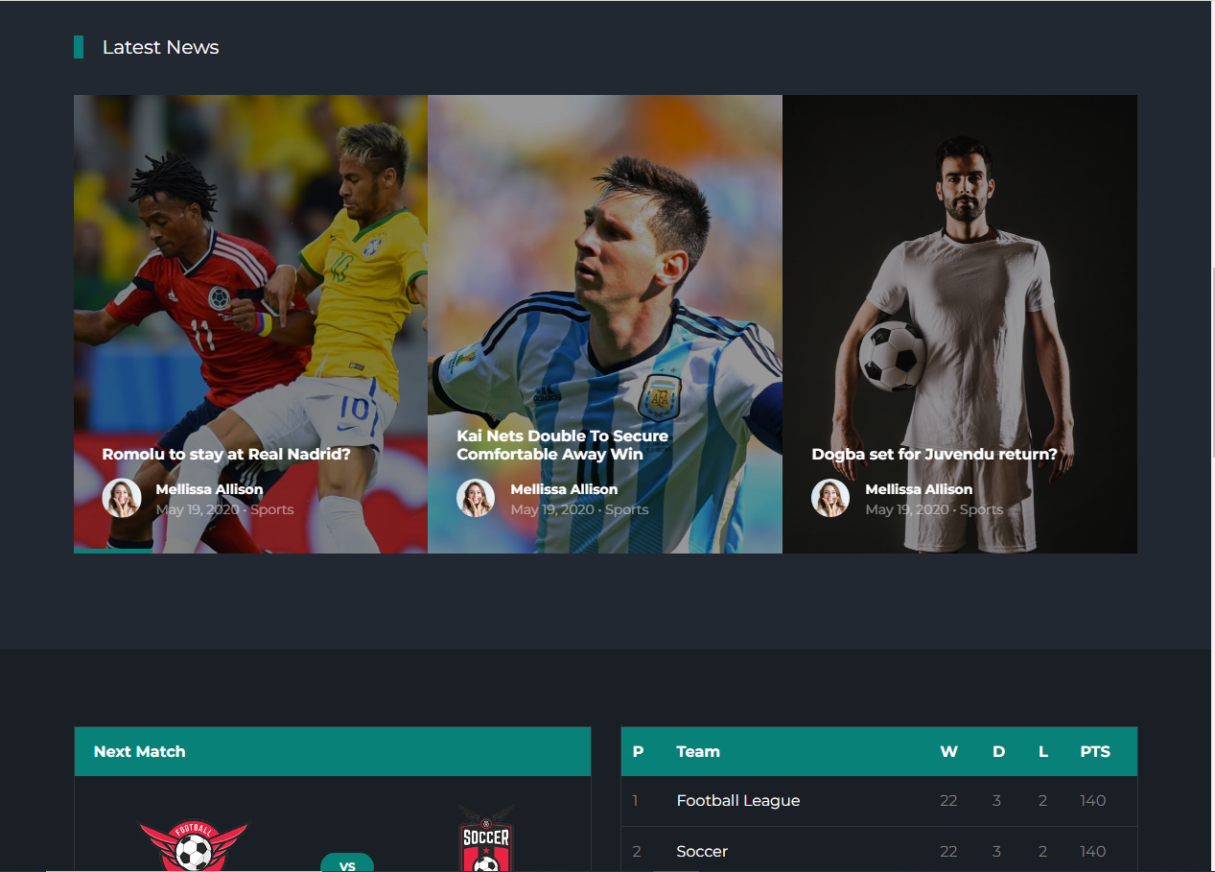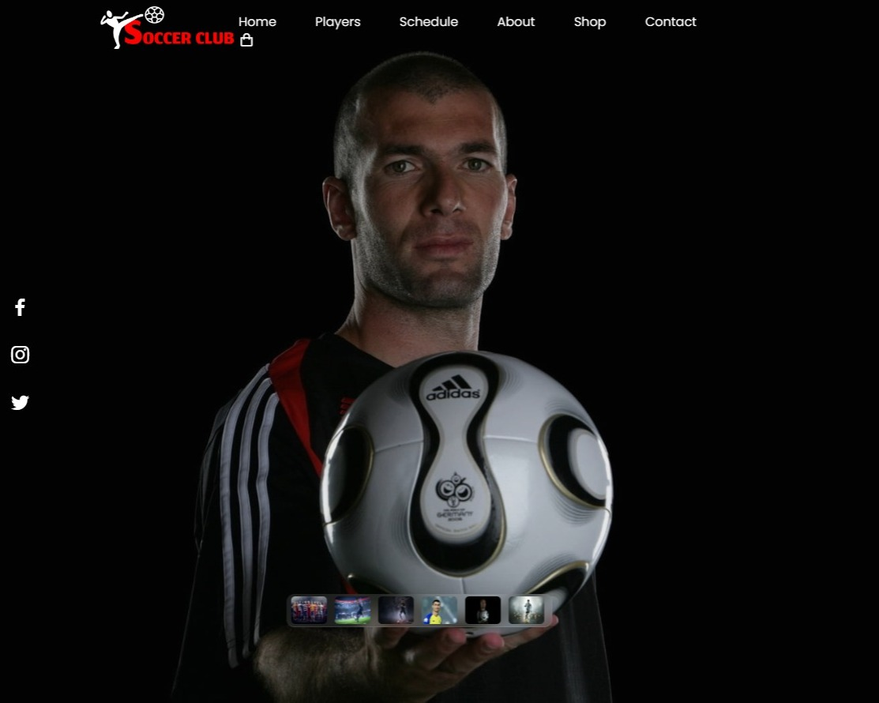**Interactive Multimedia:** Our website integrates photo galleries, videos, and highlights to engage users visually and emotionally.
  1. **Purpose of the Document**

The purpose of the document is to outline the key features and functionalities of the Soccer Club's website. The Soccer Club's website is designed to serve as a multifunctional hub for soccer enthusiasts and players. It offers real-time match updates, insights into player performances, and a platform for purchasing high-quality soccer accessories. Through the user login and admin login features, the website ensures data protection while enhancing the user experience. The website aims to strengthen the connection between the soccer club, its players, and its dedicated fan base.

* **Scoreboard and Match Information:** The scoreboard section on the website aims to keep users updated on the latest match scores, schedules, and results. Users can track the performance of the soccer club in various leagues and tournaments, fostering a sense of engagement and excitement among fans.
* **Top 10 Players:** This section showcases the top 10 players of the soccer club, offering detailed profiles and statistics for each player. It allows fans to learn more about their favourite athletes, fostering a deeper connection between players and supporters.
* **About Us:** The "About Us" section provides an overview of the soccer club's history, values, and achievements. It serves to establish a strong identity for the club and helps visitors understand the club's mission and dedication to the sport.
* **Merchandise Accessories:** The e-commerce section offers a range of soccer accessories, including soccer balls, cleats, shoes, and gloves. This section is designed to cater to players of all levels, from beginners to professionals, providing them with quality gear that enhances their performance on the field.



* 1. **Scope of Project**

The scope of the project encompasses the design, development, and implementation of a comprehensive website named "Soccer Club." The website aims to provide users with a dynamic platform to access essential information about the soccer club, its matches, players, and merchandise, and facilitate secure interactions through user and admin logins.

* **Scoreboard and Match Information:**

- Real-time scoreboard displaying match schedules, results, and scores.

- Integration with backend systems to ensure accurate and timely updates.

- User-friendly interface for easy navigation and match tracking.

* **Top 10 Players:**

- Detailed profiles and statistics of the top 10 players in the soccer club.

- Information including player biographies, achievements, and performance metrics.

- Interactive design to engage users and promote player-fan connection.

* **About Us:**

- A dedicated section highlighting the soccer club's history, values, and mission.

- Engaging content to communicate the club's identity and dedication to the sport.

- Multimedia elements such as images and videos to enhance the storytelling.

* **Data Security and Privacy:**

- Implementation of robust security measures to safeguard user data.

- Compliance with data protection regulations to ensure user privacy.

* **Responsive Design:**

- Development of a responsive and mobile-friendly website design.

- Ensuring optimal user experience across various devices and screen sizes.

* **Testing and Quality Assurance:**

- Thorough testing of all website features and functionalities.

- Identification and resolution of any bugs or performance issues.

* **Documentation and Training:**

- Creation of user guides for seamless navigation of the website.

- Training materials for administrators to effectively manage and update the website.

* **Maintenance and Support:**

- Ongoing maintenance to ensure the website's performance and security.

- Prompt support for user inquiries, technical issues, and updates.

.

* 1. **Ecommerce Store:**
* Login: This function allows users to log in to their account on the website.
* Product Search: This function allows users to search for products on the website.
* Product Details: This function displays the details of a specific product on the website.
* Product Listing: This function displays a list of products on the website.
* Shopping Cart: This function allows users to add products to their cart and checkout.
* Checkout: This function allows users to complete their purchase and pay for their products.
* Order History: This function allows users to view their order history on the website.
* Contact Us: This function allows users to contact the website's customer support team.



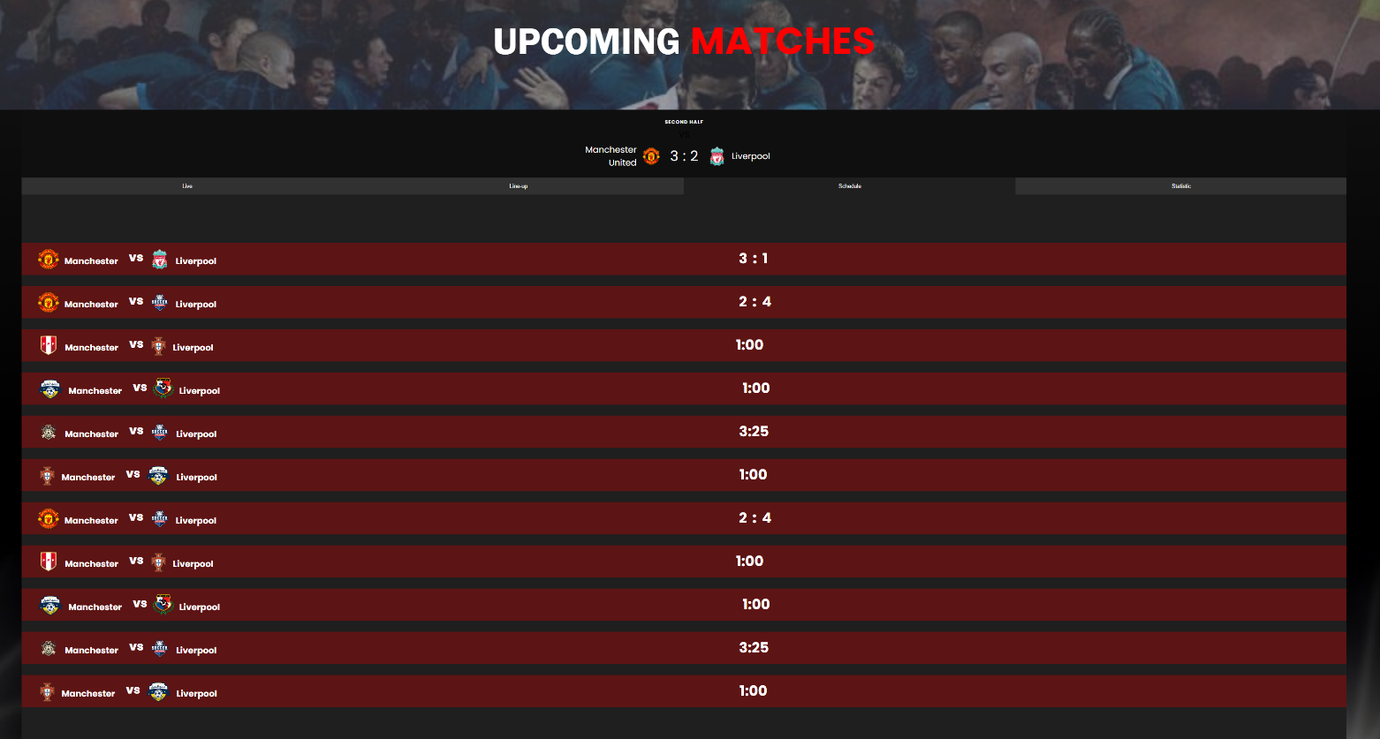

* 1. **Constrain**

Our Soccer Club website aims to offer a more engaging, informative, and user-centric experience that sets it apart from others in the industry.

The Soccer Club website will prioritize a user-friendly and intuitive navigation system for seamless browsing. We will ensure real-time updates to keep users informed with accurate and current data. Our website will incorporate interactive features like live scoreboards, player stats, and engaging multimedia content. Our e-commerce section will focus on a streamlined shopping experience, offering various payment methods for user convenience. The website’s user login feature will enable personalized profiles, order history, and recommendations. We will prioritize user data protection through secure logins and robust encryption protocol. Our website will feature a responsive design, ensuring a seamless experience across devices.



* 1. **Functional Requirements**

The objective of this document is to outline the functional requirements for the soccer club website, which will provide users with access to match scoreboards, merchandise selection (including soccer shirts, soccer cleats, soccer gloves, and soccer balls), and a user-friendly ordering system.

* **Match Scoreboards:**

- The website shall display the live scores, team names of ongoing matches.

- The scoreboard shall update in real-time without requiring manual page refresh.

* **Responsive Design:**

-The website shall be responsive and accessible across various devices, including desktops.

**Catalog Display:**

* 1. **Non-functional requirements**
* **Performance:** Our website would be loaded within 3 seconds on both desktop and mobile devices to ensure a seamless user experience. The website will be able to handle a minimum of 500 simultaneous users during peak traffic times without any noticeable slowdown.
* **Reliability:** Our website will have an uptime of at least 99.9% to ensure it is available to users whenever they access it.
* **Usability:** The user interface is intuitive and user-friendly, enabling users to easily navigate between match scoreboards, merchandise pages, and the ordering process. Responsiveness is essential, which will ensure that the website is accessible and usable on various devices and screen sizes.
* **Compatibility:** The website will be compatible with popular web browsers (Chrome, Firefox, Safari, Edge) and their latest versions. Mobile responsiveness is also ensured across different devices and operating systems.

**Technical Considerations:**

* We have used HTML5, CSS3, Bootstrap, jQuery and JavaScript to build the User Interface (UI).
* We have ensured that the application is responsive and compatible with different

Screen sizes.

* 1. **Interface requirements**
* **Hardware**

1. Intel Core i5 Processor
2. 8 GB RAM
3. Color SVGA
4. 500 GB Hard Disk space
5. Mouse
6. Keyboard

* **Software**

1. Frontend: HTML5, CSS3, Bootstrap , JavaScript, jQuery.
2. Text Editor: Visual Studio Code.

